Bank Account Verification (Penny Drop)

Bank Account Verification APIs can be used to verify the bank account number provided by an individual or a  business. It runs on IMPS platform powered by National Payment Corporation of India (NPCI)

|  |  |
| --- | --- |
| **POST** | **{BASE_URL}/client/verify/bank_account** |

**Headers:**

|  |
| --- |
| **authorization:**  “Basic  Base64encodedValueOf(**client_id**:**client_secret**)”  **content-type** : “application/json” |

**Use Case : Default, Re 1. Credit to customers bank account**

|  |
| --- |
| **Request** |
| **{**  **"beneficiary_account_no" : "123110023204445",**  **"beneficiary_ifsc": "UTIB0000888"**  **}** |

**Use Case : Custom, Re 1 + any amount of corporate choice (max upto Rs. 2), credit to customers bank account**

|  |
| --- |
| **Request** |
| **{**  **"beneficiary_account_no" : "123110023204445",**  **"beneficiary_ifsc": "UTIB0000888",**  **"amount": "1.20",**  **}** |

|  |
| --- |
| **Response Success** |
| {      "id": "FTI1901091725336218AA5CB1LMWHM1E",      "verified": true,      "verified_at": "2019-01-09 17:25:39",      "beneficiary_name_with_bank": "DUMMY CUSTOMER NAME"  } |
| **Please note** : In a sandbox environment you will get “DUMMY CUSTOMER NAME” always as a hardcoded value. In production you will get the actual name of the beneficiary associated with the account uptol 20 characters. |

|  |
| --- |
| **Response Failure** |
| {     "id": "R9SGBH61RO3L15Q",     "verified": false,     "error_msg": "Invalid beneficiary account details"  } |

|  |
| --- |
| **Response Failure** |
| {        "id": "FTI1809111232556634TGAOUXJM5LLUY",        "verified": false,        "error_code": "es405",        "error_message": "Some error message"  } |

**List of error codes & messages**

Note: Please consider the highlighted error codes and error messages for key reasons

|  |  |  |  |  |  |
| --- | --- | --- | --- | --- | --- |
| **statusCode** | **subStatusCode**  **(error code)** | **Meaning**  **(error message)** | **When Does it Come?** | **Recommended Action** | **Error type** |
| FAILED | ns:E402 | Insufficient Balance in debit account, payment required | When account to be debited doesn't have sufficient funds | Fund the debit account and retry, contact DIGIO : support@digio.in |  |
| FAILED | ns:E405 | Invalid Transfer Type | The Transaction Type is not from the list specified | Retry the transaction with a valid transferType or with ANY | Business |
| FAILED | ns:E429 | (Limit Daily/transaction/rate) exceeded | Number of requests that have come from you have exceeded the permissible limit set by an upstream system | Retry next day | Business |
| FAILED | ns:E406 | Beneficiary not acceptable | Problem with beneficiary account | check with beneficiary bank | Business |
| IN_PROCESS |  |  | Transaction timed out during execution | Check status after 30 minutes and retry if FAILED | Technical |
| FAILED | ns:E504 | Gateway Timeout Error | An upstream service returned an unexpected error | Check status after 30 minutes and retry if FAILED | Technical |
| FAILED | ns:E502 | Bad Gateway | An upstream service returned an unexpected error | Contact Support | Technical |
| FAILED | ns:E1001 | The transaction amount exceeds the maximum amount for IMPS | Transaction Amount exceeds IMPS Maximum Limit | Check Internally | Business |
| FAILED | ns:E1002 | The transfer currency is not supported. Supported currency is INR | Transfer Currency is other than 'INR' | Pass 'INR' in transfer currency and | Business |
| FAILED | ns:E1003 | The transaction amount should be multiples of Re 1 for RTGS | Transfer Amount is in fraction. | Retry after correcting the transfer amount | Business |
| FAILED | ns:E1004 | Transfer Amount is less than the minimum amount for RTGS | Transaction Amount is less than RTGS Minimum amount | Check transfer type and amount and retry | Business |
| FAILED | ns:E6000 | Purpose Code not found | Purpose Code passed in the request does not exist in system | Check Internally | Business |
| FAILED | ns:E6001 | Only registered beneficiaries are allowed for this purpose code | Check beneficiary code if registered and retry | Check Internally | Business |
| FAILED | ns:E6002 | Purpose Code is required for this customer | Pass purpose code | Check Internally | Business |
| FAILED | ns:E8000 | A transaction with the same reference number is already processed or under processing | UniqueRequestNo has already come before for a successful transaction | Retry with a new UNR | Technical |
| FAILED | ns:E6003 | Invalid Debit Account for Customer | When debit account no does not exist in the customer set up | Contact Support | Business |
| FAILED | flex:E18 | Hold Funds Present - Refer to Drawer ( Account would Overdraw ) |  | Account is in hold status. Contact Support. | Business |
| FAILED | flex:E404 | No Relationship Exists with the debit Account {AccountNo} and partner |  | Contact Support | Technical |
| FAILED | flex:E8036 | NEFT - Both Customer Mobile and Email is not valid. |  | Issue with Remitter Account setup. Contact support | Technical |
| FAILED | flex:E8087 | To Account Number is Invalid |  | Retry with correct Beneficiary/customer Account | Business |
| FAILED | flex:E9072 | Invalid IFSC Code |  | Retry with correct beneficiary IFSC Code | Business |
| FAILED | npci:E08 | Acquiring Bank CBS or node offline |  | Beneficiary bank node offline. Retry later | Technical |
| SENT_TO_BENEFICIARY |  |  | IMPS: Transaction accepted by NPCI but no response received from beneficiary bank within the time limit set NEFT: Transaction has been accepted by RBI but the acknowledgement has not yet been received | IMPS: Check status after 1 hour. Transaction status expected to clear to COMPLETED/FAILED after 2 working days in most cases. NEFT: Check status after 3 hours in NEFT working window. |  |
| FAILED | npci:EM1 | Invalid Beneficiary MMID/Mobile Number |  | Retry with correct MMID/Mobile Number | Business |
| FAILED | npci:EM2 | Amount limit exceeded | Transaction Amount exceeds IMPS Maximum Limit | Retry with Transfer Type NEFT or ANY | Business |
| FAILED | npci:EM3 | Account blocked/frozen |  | Contact Support. | Business |
| FAILED | npci:EM4 | Beneficiary Bank is not enabled for Foreign Inward Remittance |  | Beneficiary account is an NRE Account. Domestic Transactions not permitted. This will not come for Inward Remittance Via RDA/MTSS | Business |
| FAILED | npci:EM5 | Account closed |  | Beneficiary account is closed. | Business |
| FAILED | atom:E404 | No Relationship Exists with the debit Account {AccountNo} and partner |  | Contact Support | Technical |
| SCHEDULED_FOR_NEXT_WORKDAY |  |  | This will come for NEFT when the transaction has been received post cut off time or on a holiday | Check status on next working day |  |
| RETURNED_FROM_BENEFICIARY | sfms:E62 |  | Transaction accepted by RBI but beneficiary bank rejected it. | Give back money | Business |
| FAILED | sfms:E99 | Manually Marked in Error | Transaction is in error due to issue with the transaction details. | Give back money | Business |
| FAILED | sfms:E70 | Outward Transaction Rejected |  | Give back money | Business |
| FAILED | sfms:E18 | Rejected by SFMS | Transaction is not accepted by the payment body. | Give back money | Business |
| COMPLETED | R000 |  | Remittance transactions has been successfully processed |  |  |

1.6.7 PENNY DROP

The Penny Drop step is used to enter the user’s bank account number and verify that it exists and is active, by dropping 1 INR into that account. The account beneficiary’s name is also returned as a result of this step.

Custom Penny Drop is when a random amount between 1 and 2 INR is dropped into the customer’s Bank Account by IMPS and the user is asked for a confirmation of the amount credited to his/her bank account. are asked to enter the amount.

The configuration screen is as shown below:

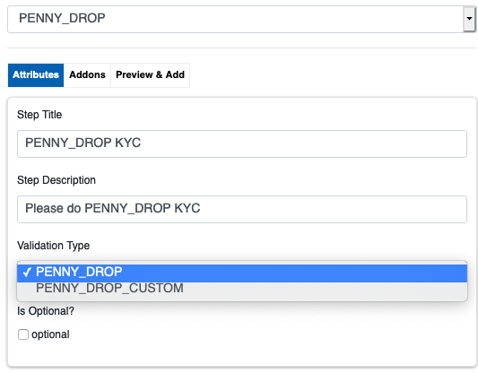

The video guide for this step can be found here: <https://youtu.be/QFHoKVADmnM>

Customer side screen for (Standard) Penny Drop:

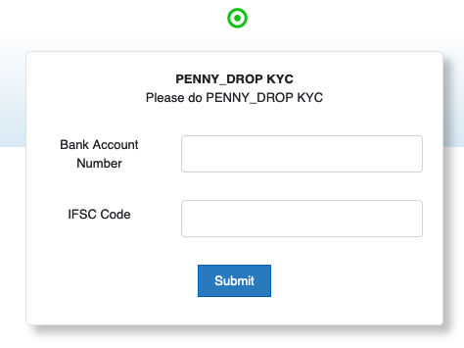

Customer side screen for Custom Penny Drop:

First, the same two fields as in the above image appear. On entering a valid Bank Account number and IFSC, a third field appears in which the amount deposited is to be entered:

